Dear student!

💻 Summary

Well done for your first submission!  
  
You have done a great job implementing the functions including cartTotal(), emptyCart() etc properly. 🎉  
  
And cart functionality of addProductToCart(), increaseQuantity() work without any technical issue, very good! 👍  
  
I've made comments on 3 issues, below, that can help you improve your project!  
Please look into the feedback(s), and change your code accordingly.

⚠️ Issue(s) to be solved

* 1️⃣ pay(amount): takes in an amount from the text field and checks if the amount is greater or less than the value returned from cartTotal().
* 2️⃣ Helper functions are used instead of repeating code.
* 3️⃣ Concise comments document the code. done

🔑 Next step(s) you should take to solve the issue(s)

* 1️⃣ Inside the pay() function, you should also call emptyCart() function in order to make the cart variable to be **an empty list** so that the value of cartTotal() becomes 0 when balance is greater than or equal to 0.
* 2️⃣ Declare a new function, getProductById(), and use the function as needed instead of writing the same code manually throughout script.js
* 3️⃣ Only put descriptive comments right above the functions.

🍀 I appreciate your hard work for the project. Hang in there, and I wish you all the best!  
  
🔑 We will see if your project needs further improvement after you fix the issues that are described in the **Code Review**.  
  
Keep Udacious!💪

**Write JavaScript functions to implement checkout functionality**

**Reviewer Note**

✅ Meets requirement(s):

* ✅ cartTotal(): calculates and returns the total cost of all products in the cart. Use price and quantity to calculate the total cost.
* ✅ All functions should be created using function declaration.
* ✅ A global variable is created to hold the value of the remaining balance.

❗️ Needs to be changed:

* ❌ pay(amount): takes in an amount from the text field and checks if the amount is greater or less than the value returned from cartTotal(). In this function, the amount argument represents the money paid by the customer. Returns the positive or negative difference.  
  👉 See the feedback on Line 130 in script.js

📚 Resource:

* [**JavaScript: Number toFixed() method(opens in a new tab)**](https://developer.mozilla.org/en-US/docs/Web/JavaScript/Reference/Global_Objects/Number/toFixed)

Javascript functions are created to implement the required functionality:

* cartTotal(): calculates and returns the total cost of all products in the cart. Use price and quantity to calculate the total cost.
* pay(amount): takes in an amount from the text field and checks if the amount is greater or less than the value returned from cartTotal(). In this function, the amount argument represents the money paid by the customer. Returns the positive or negative difference.

All functions should be created using function declaration.

A global variable is created to hold the value of the remaining balance.

**Follow JavaScript Best Practices**

**Reviewer Note**

✅ Meets requirement(s):

* ✅ Code uses let and const instead of var.
* ✅ Indenting is consistent -- either 1 tab, 2 spaces, or 4 spaces. No mixing tabs and spaces.
* ✅ Function and variable names are meaningful.
* ✅ All console.log statements used for debugging have been removed.

❗️ Needs to be changed:

* ❌ Helper functions are used instead of repeating code.  
  👉 See the feedback on Line 53 in script.js  
  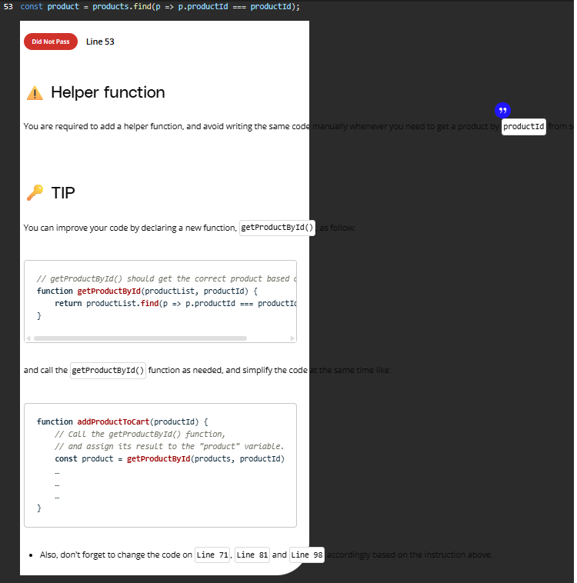
* ❌ Concise comments document the code.  
  👉 See the feedback on Line 70 in script.js  
  A screenshot of a computer

  AI-generated content may be incorrect.

📚 Resources:

* [**JavaScript best practices to improve code quality(opens in a new tab)**](https://app.deepsource.com/blog/javascript-code-quality-best-practices/)
* [**Difference between var, let and const keywords in JavaScript(opens in a new tab)**](https://www.geeksforgeeks.org/difference-between-var-let-and-const-keywords-in-javascript/) -> An amazing article about the difference between var, const and let
* Code uses let and const instead of var.
* Indenting is consistent -- either 1 tab, 2 spaces, or 4 spaces. No mixing tabs and spaces.
* Function and variable names are meaningful.
* All console.log statements used for debugging have been removed.
* Helper functions are used instead of repeating code
* Concise comments document the code

